PROJECT ON DIGITAL MARKETING

**NAME:** THIRUVARASAN. VR

**TEAM MEMBERS:**

VIGNESH KANNA. B S (8555D655B967DF59C4A4E565EDF4A826 - TEAM LED)

ESSAKI RAJA. S (7F628DE747D5C4396DE4C59E39B4D27C)

THIRUVARASAN. V R(BB47C5A719B532D86E549COB8B1CE741)

VIGNESHWARAN. N(D629A359EAFCAED8408416BED2069C27)

**TEAM NM ID:** NM2023TMID03455

**DEPARTMENT:** COMPUTER SCIENCE AND ENGINEERING -FINAL YEAR

**COLLEGE:** DHANALAKSHMI SRINIVASAN INSTITUTE OF TECHNOLOGY, SAMAYAPURAM, TRICHY.

**NAAN MUDHALVAN COURSE:** DIGITAL MARKETING

PROJECT DESCRIPTION

**BRAND NAME**: DOLPHIN AQUARIUM

**CATEGORY:** AQUARIUM

**TARGET AUDIENCE:** ALL(MEN, WOMEN, AND KIDS)

**EMAIL:**[dolphinaqua07@gmail.com](mailto:dolphinaqua07@gmail.com)

**FACEBOOK BUSINESS PAGE:**<https://www.facebook.com/dolphin.aqu?mibextid=9R9pXO>

**DOCUMENTATION:** <https://docs.google.com/document/d/1KZSoiGCs8Xnn1oR02Lcgj7aBREg3LPfu/edit?usp=drivesdk&ouid=107163455160223421003&rtpof=true&sd=true>

**SOCIAL MEDIA POSTER:** <https://drive.google.com/file/d/1KVHdHSNYNnZ0LYeXYI5cKbgBCeHuCtdN/view?usp=drivesdk>

**RECORDED VIDEO:** [**https://youtu.be/Gp44PoqnKrk?feature=shared**](https://youtu.be/Gp44PoqnKrk?feature=shared)

**DOCUMENTATION:**

NAVIGATION:

URL: <https://www.google.com/search?q=facebook&rlz=1C1CHBF_enIN1048IN1048&oq=&gs_lcrp=EgZjaHJvbWUqCQgBEEUYOxjCAzIJCAAQRRg7GMIDMgkIARBFGDsYwgMyCQgCEEUYOxjCAzIJCAMQRRg7GMIDMgkIBBBFGDsYwgMyCQgFEEUYOxjCAzIJCAYQRRg7GMIDMgkIBxBFGDsYwgPSAQkyMTE2ajBqMTWoAgiwAgE&sourceid=chrome&ie=UTF-8>



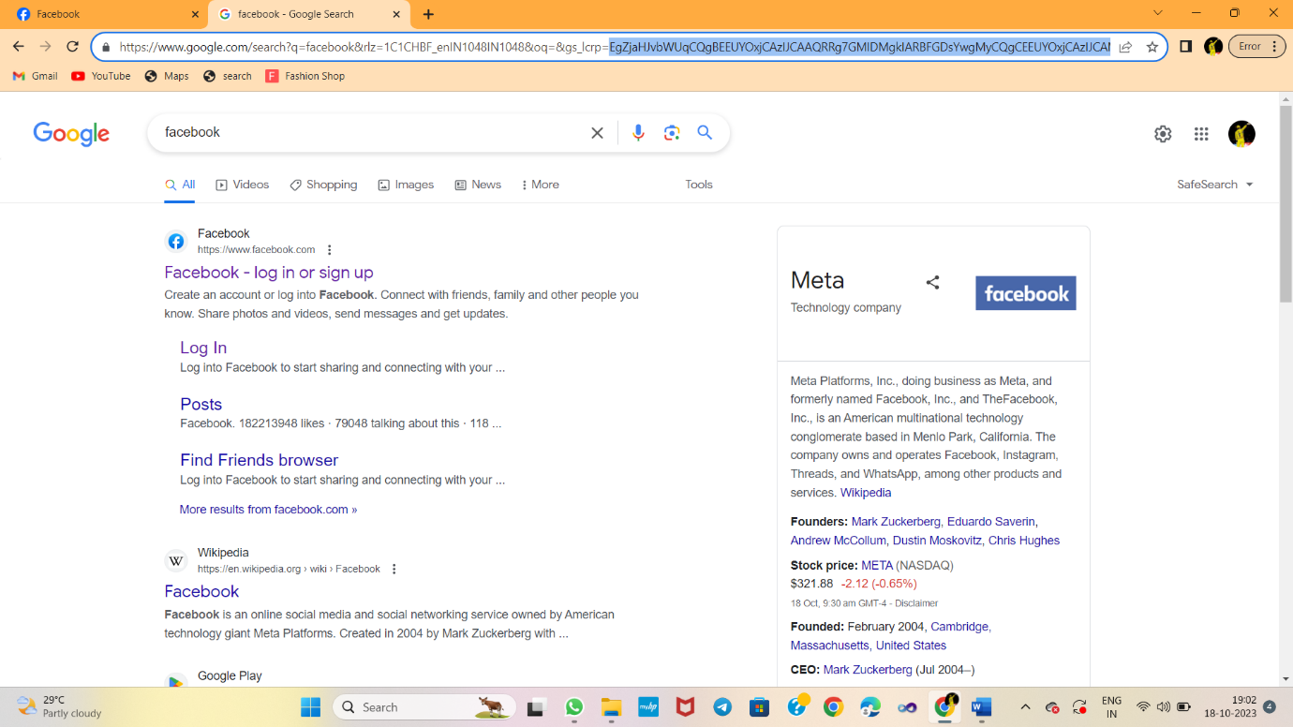

META BUSHINESS SUITE:

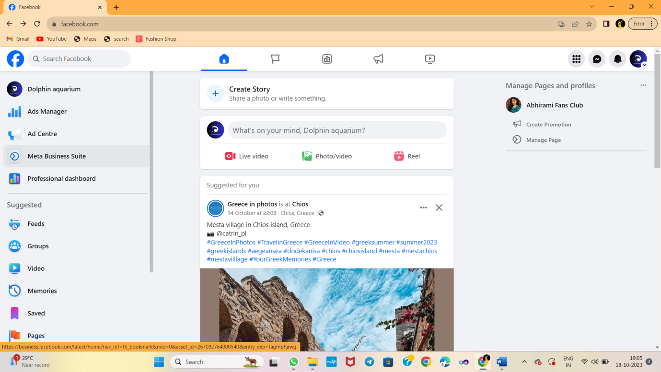

ADS:

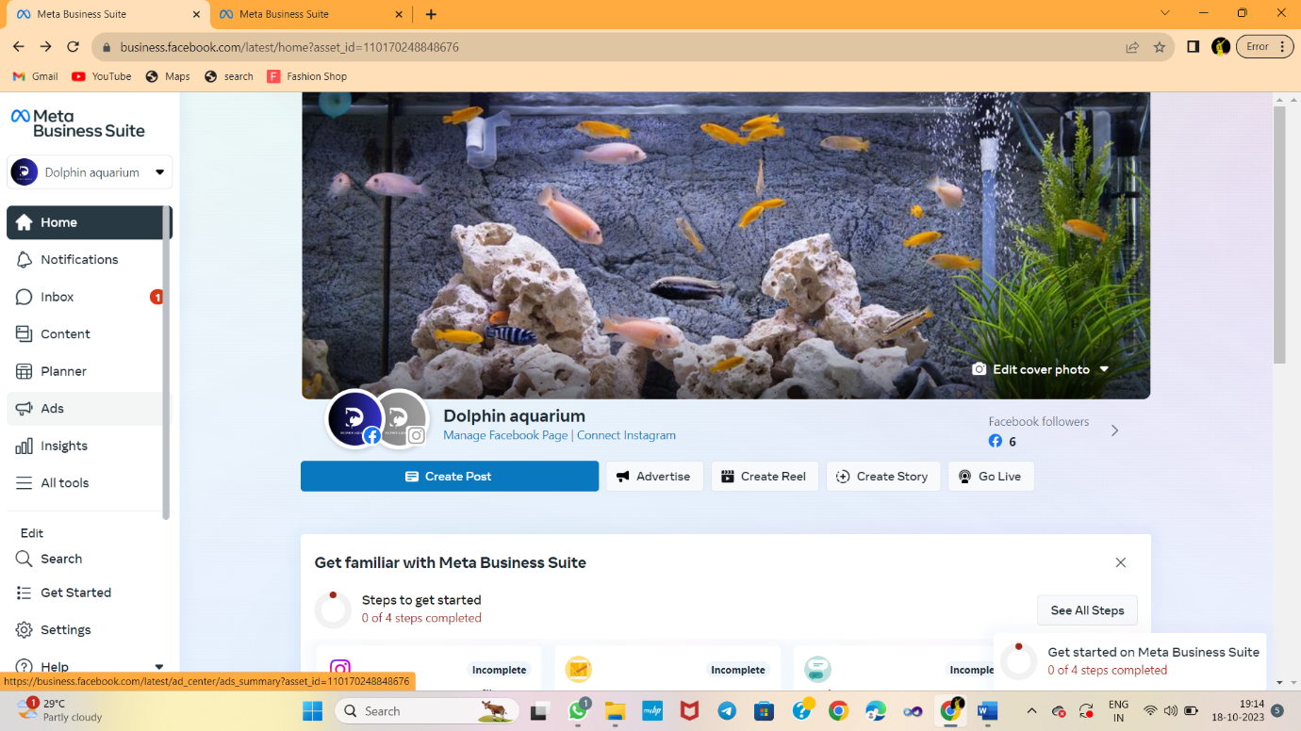

CREATE AD:

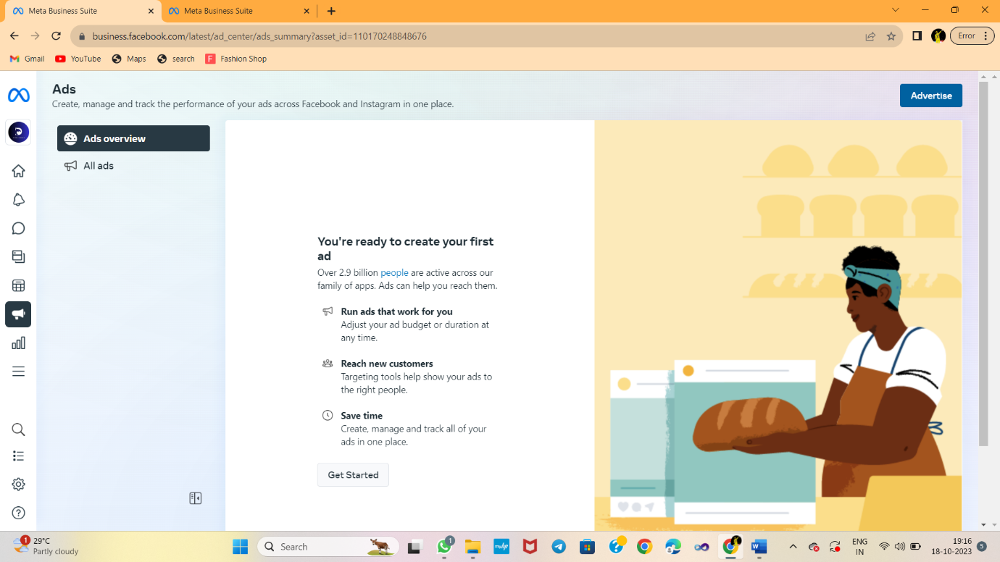

CHOOSE GOAL

CHOOSE GOAL:

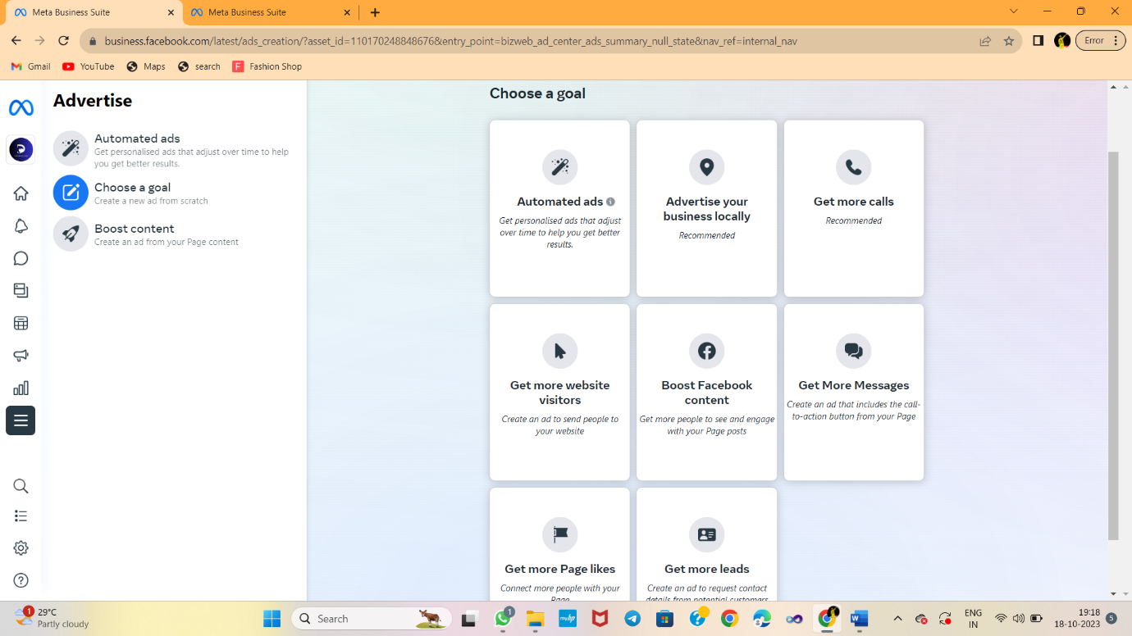

MORE LEADS:

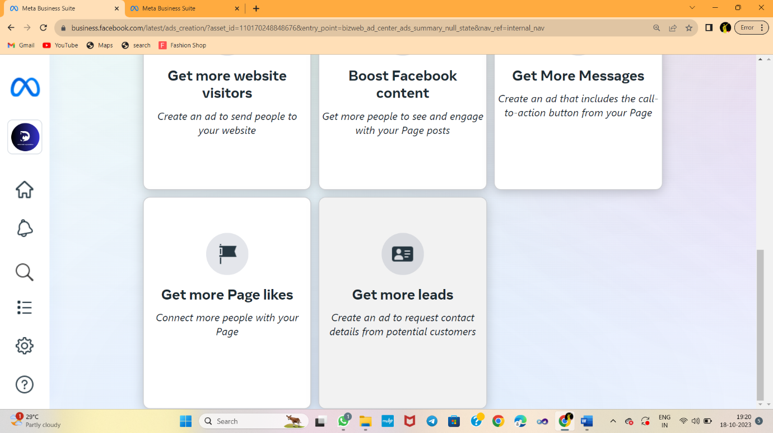

NEW FORM

NEW FORM:

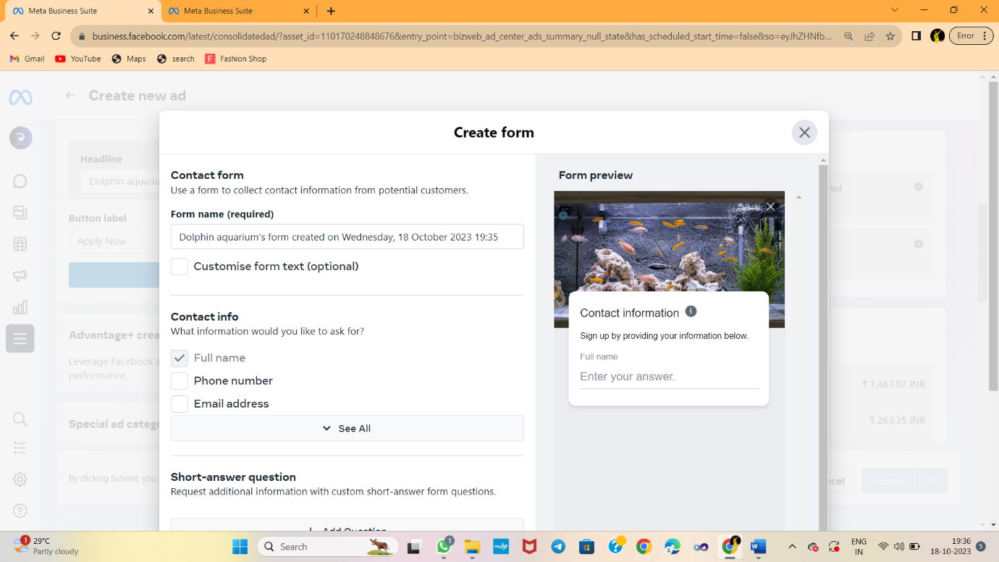

ADD DETAILS:

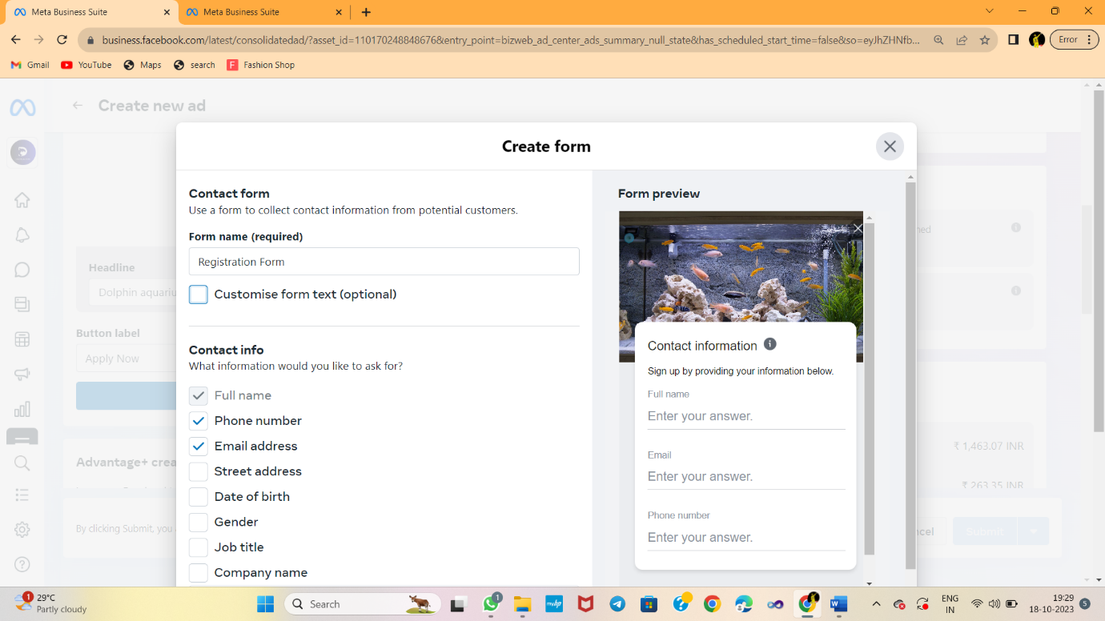

CLICK NEXT:

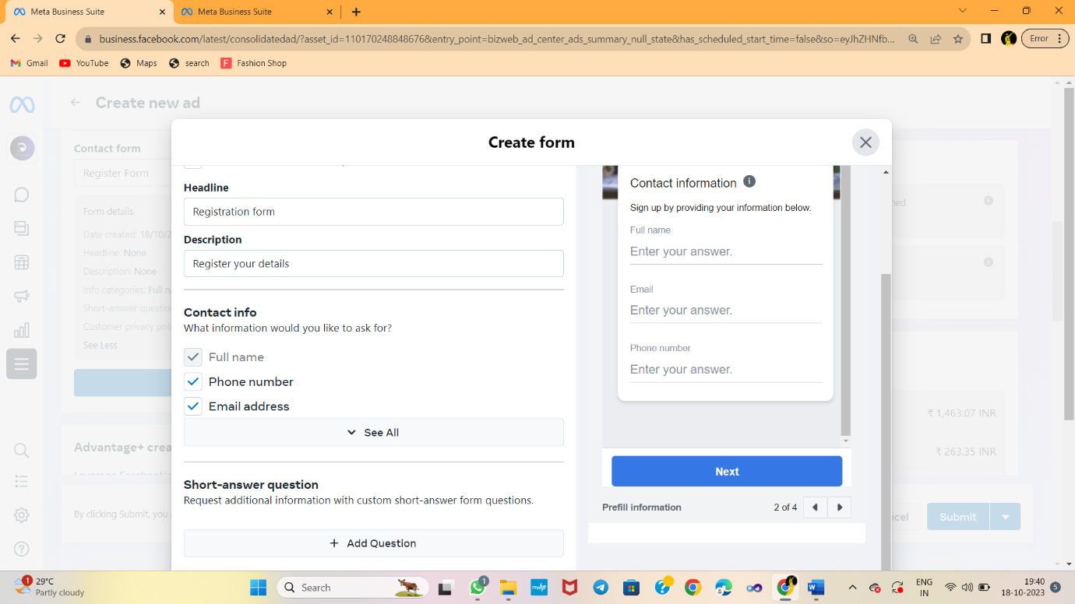

ADD DESCRIPTION:

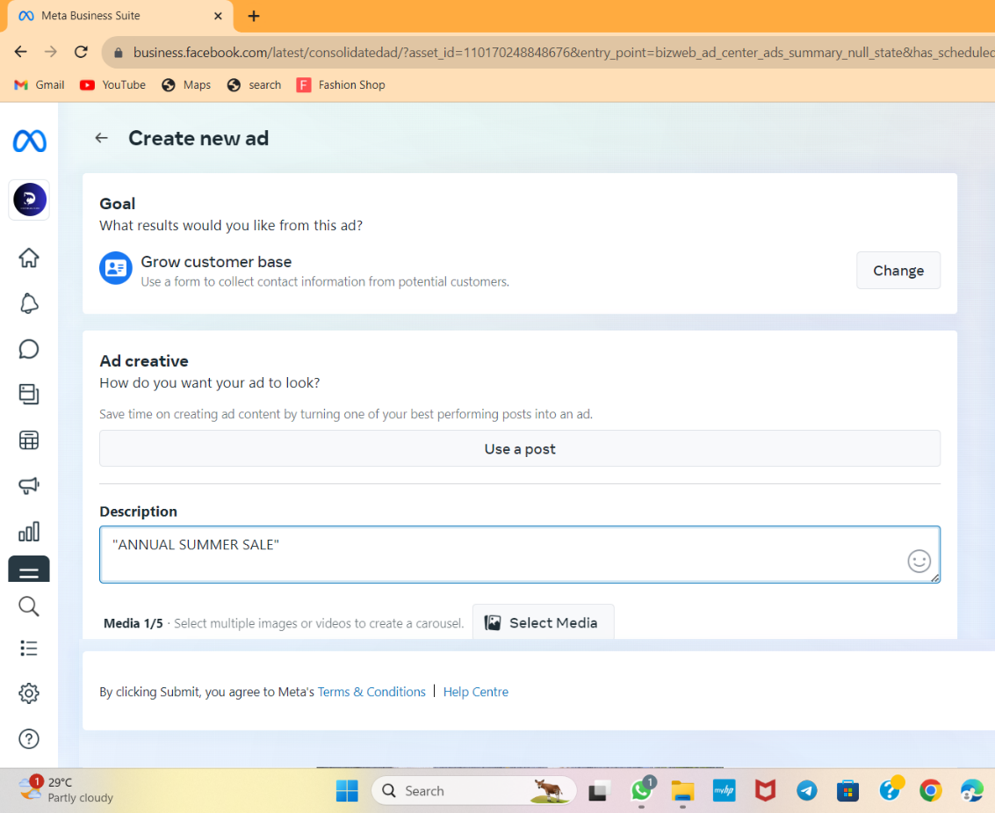

ADD MEDIA

CLICK SELECT MEDIA:

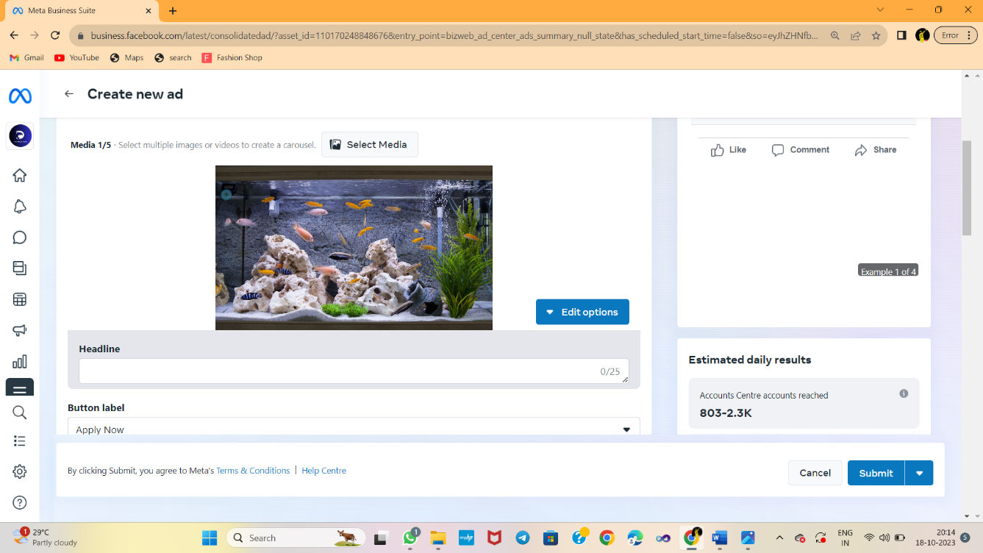

CLICK UPLOAD AND UPLOAD IMAGE FOR YOUR AD:

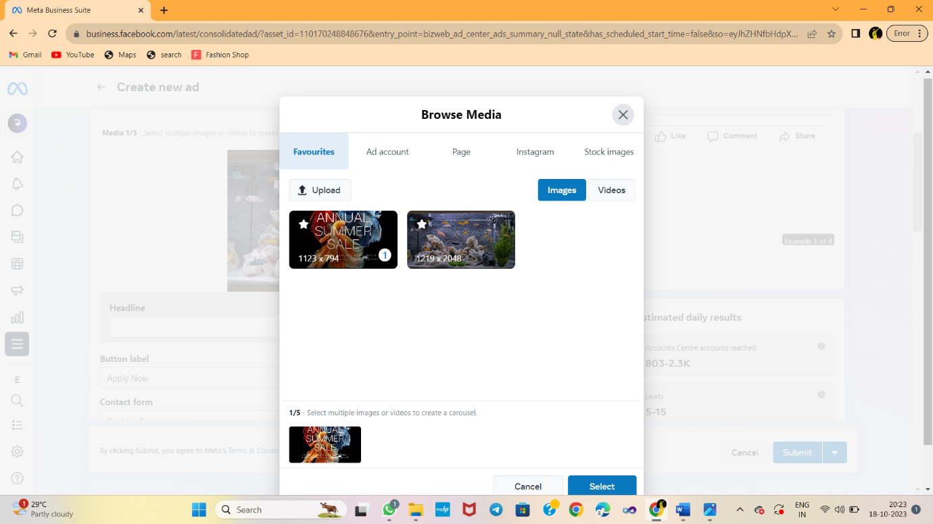

CLICK SELECT:

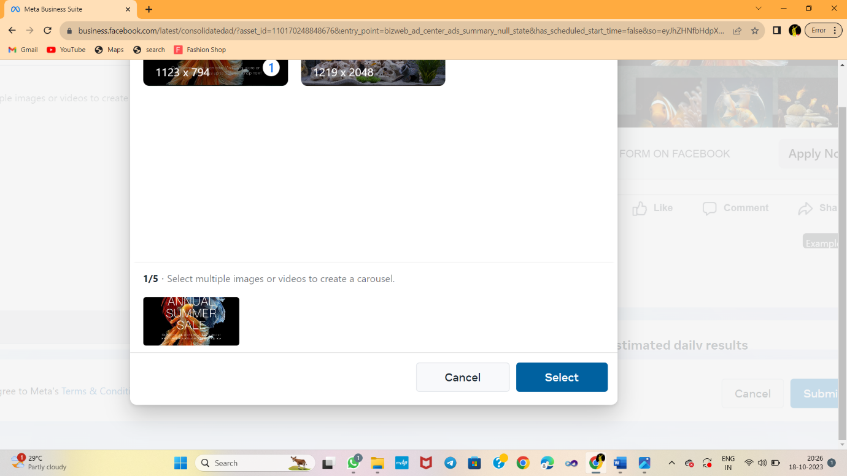

HEADLINE

HEADLINE:

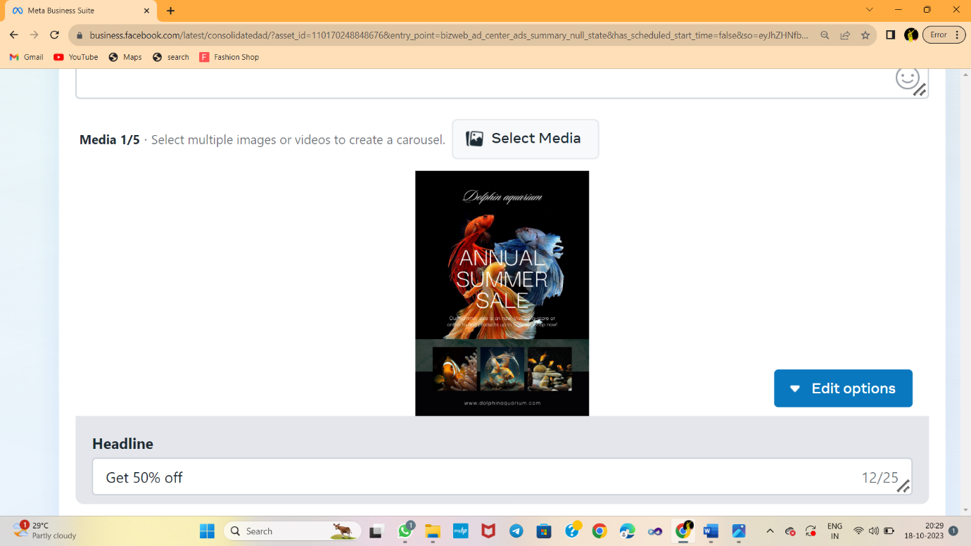

ESTIMATED RESULTS:

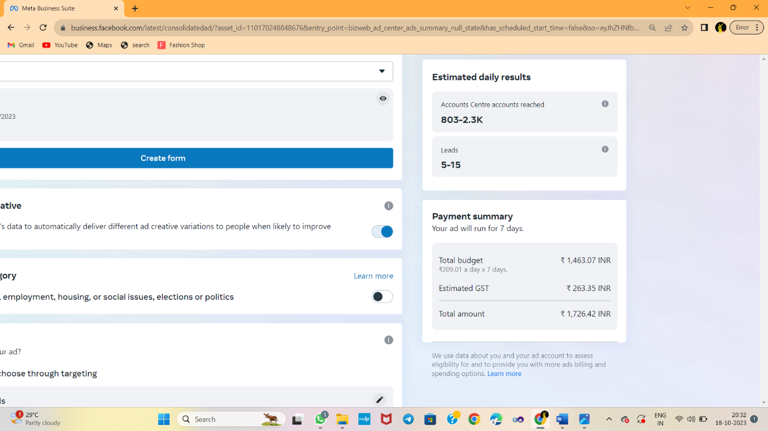

CREATE AUDIENCE

CLICK “CREATE NEW”

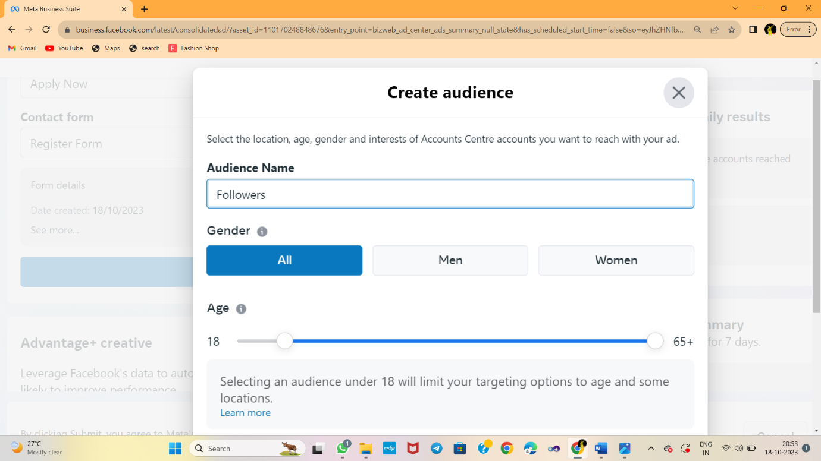

ADD LOCATION

ADD LOCATION OF YOUR AUDIENCE:

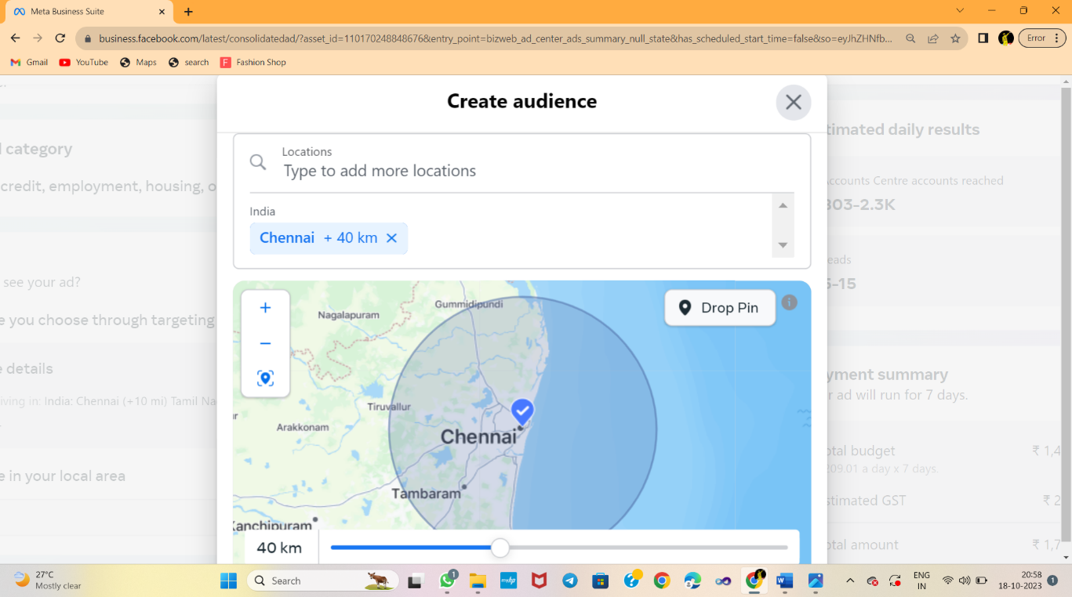

DETAILED TARGETING:

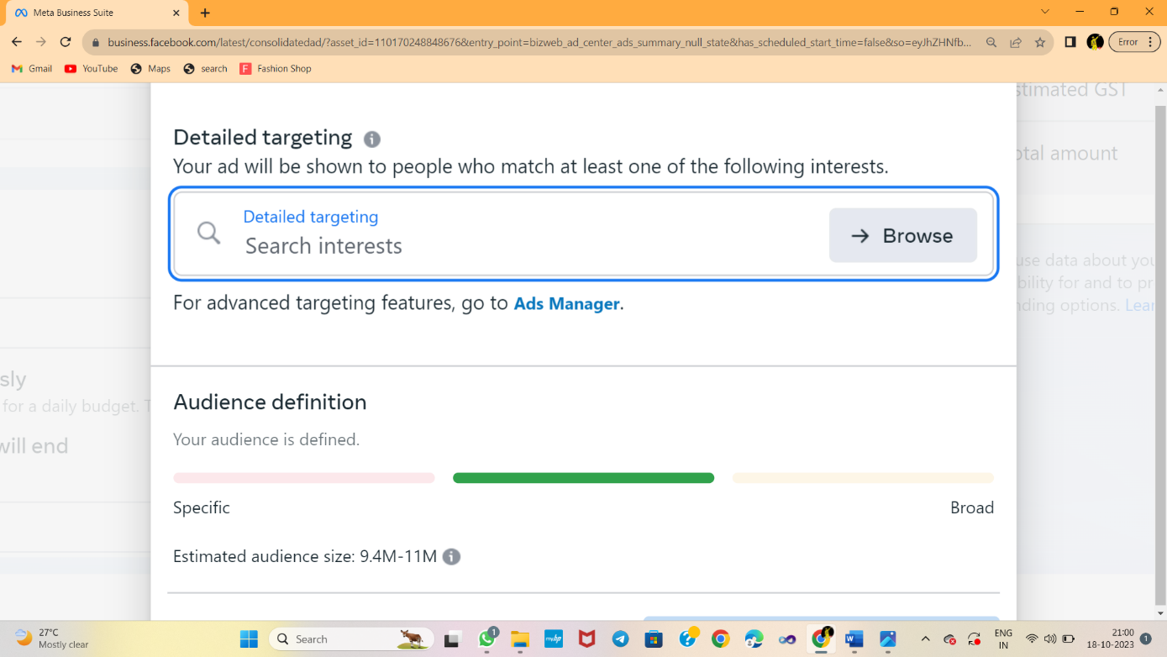

DEMOGRAPHICS, INTERESTS, BEHAVIOURS:

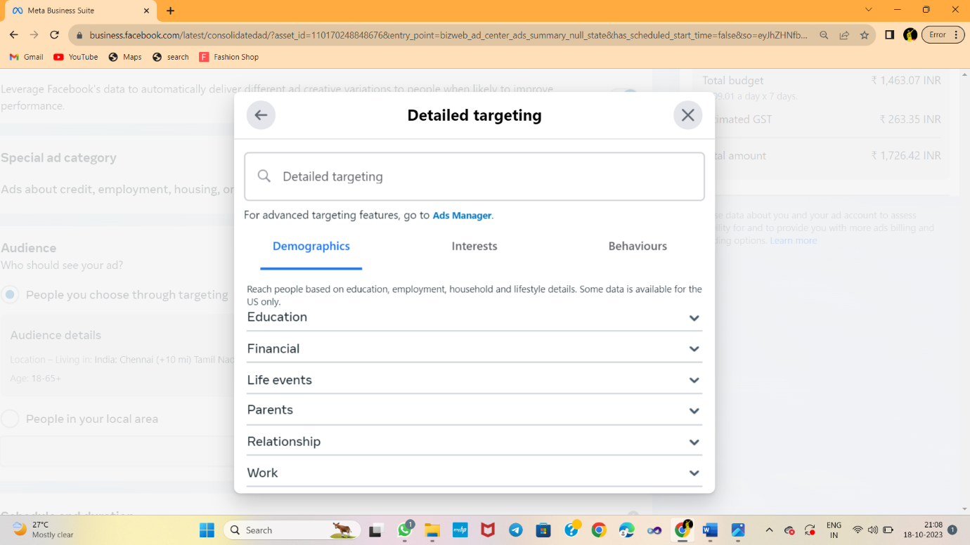

AD DURATION

CLICK BACK BUTTON:

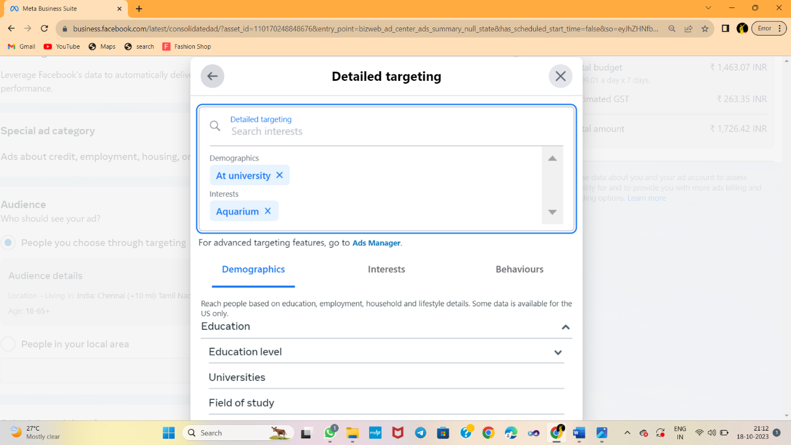

CLICK SAVE AUDIENCE:

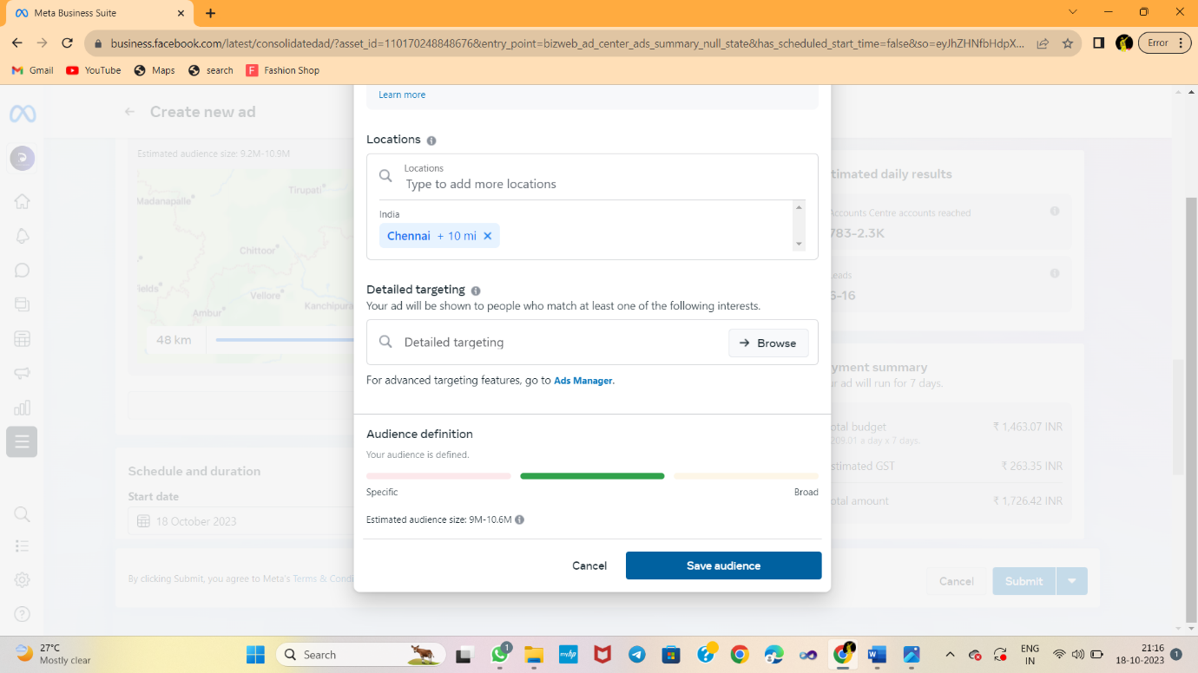

SELECT START DATE:

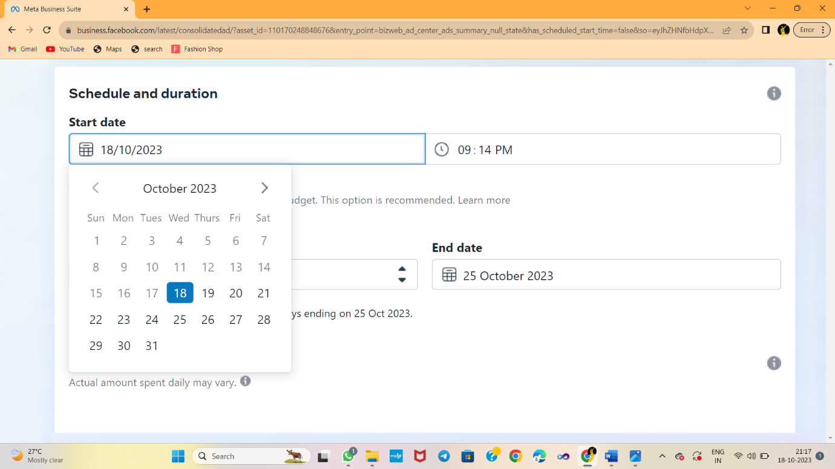

AD BUDGET:

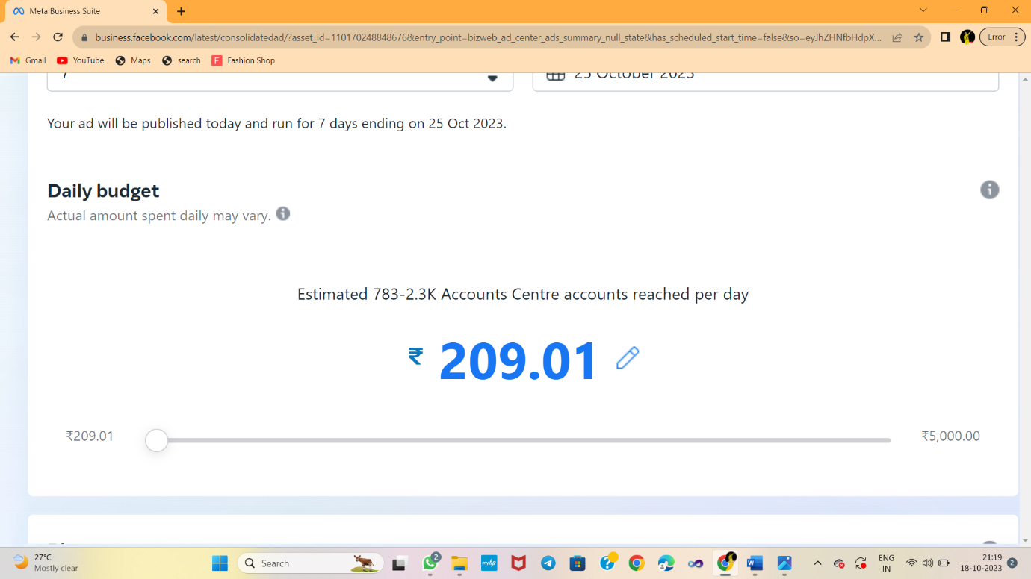

PLACEMENTS:

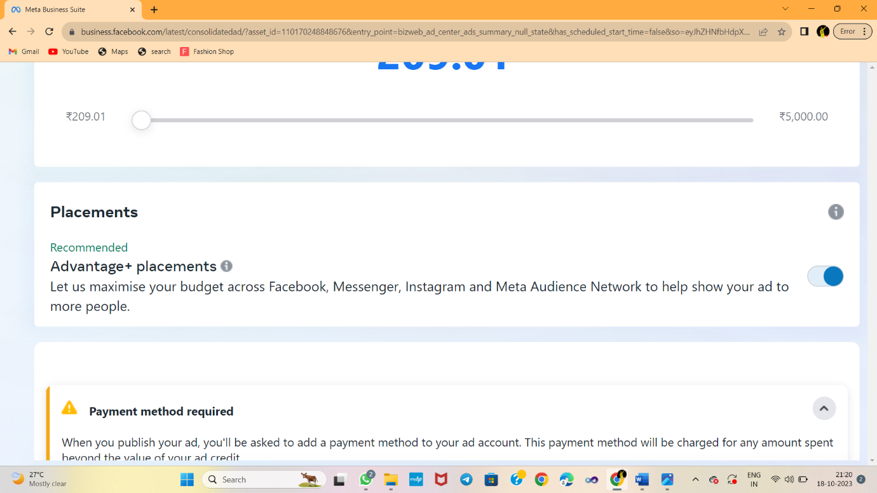

PREVIEWS

PREVIEWS:

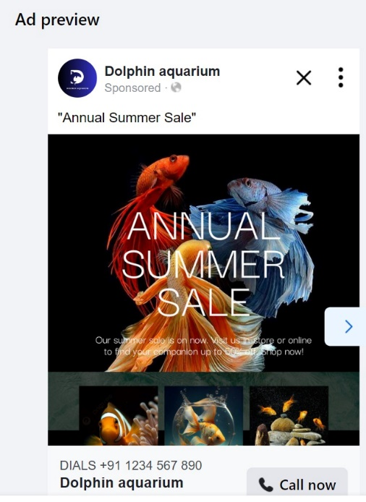

AD PAYMENT:

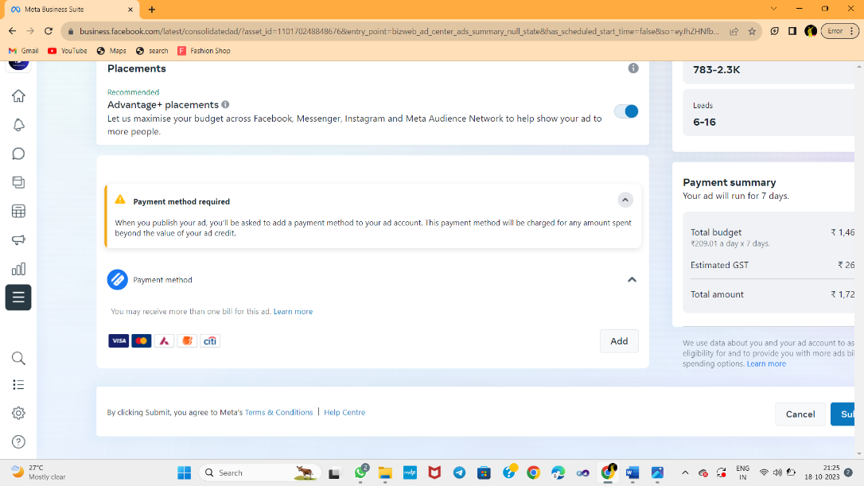

PROMOTE NOW:

